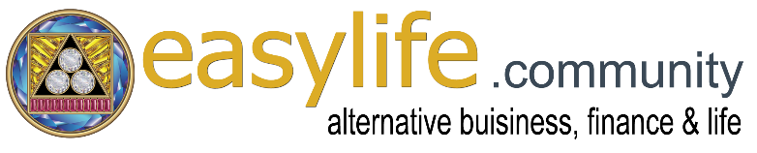
PRESS RELEASE
________________________________________
Unconditional Basic Income for All. Immediately
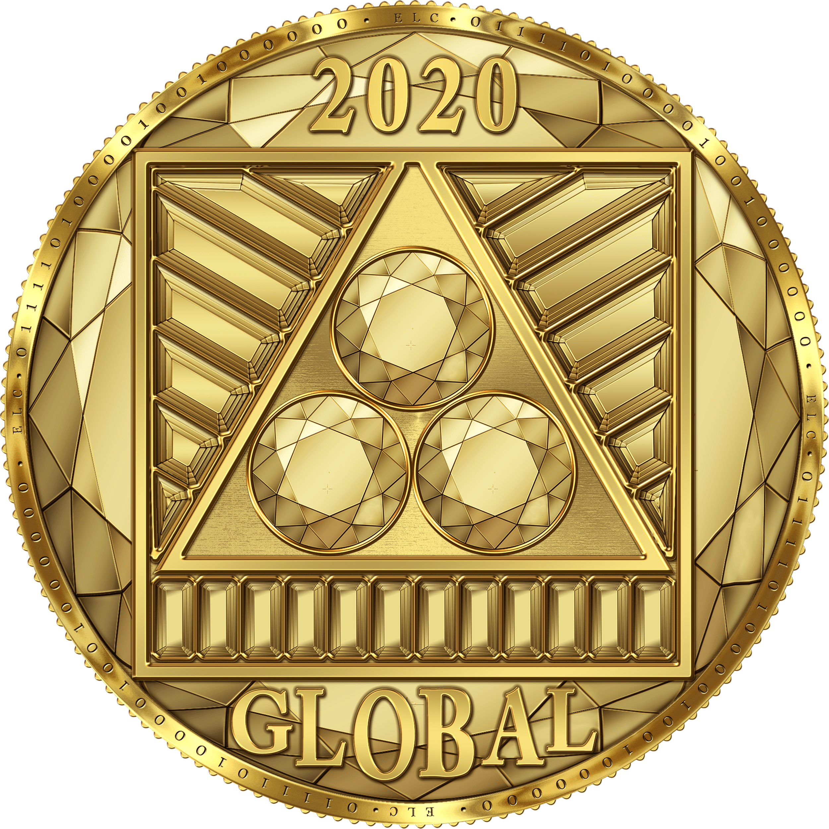
Starting December 1st, 2020 people all over the world can receive an unconditional basic income of 3,000 dollars per month.
The online platform "Easy Life Community & Blockchain Network" offers this amount to those who register on their site completely free of charge.
The creative solution of the initiator is to offer the unconditional basic income in the form of the company's own blockchain, Unconditional Basic Income, and its respective crypto currency the "GLOBAL" (Trade Code: XGB).
It is the first and only cryptocurrency in the world that is being given away for free.
All registered users of the platform, both private individuals and companies, automatically receive 50 GLOBALs per month on their user account. Since one GLOBAL corresponds to the value of one gram of gold, the unconditional basic income distributed to all members is currently (as of the beginning of 2021) around 3,000 dollars per month.
The GLOBAL can be used for shopping either in the multi-vendor market offered via the platform or in the local stores of corporate partners. It can also be exchanged for various other crypto and national currencies via the company's own online exchange.
All companies worldwide, especially sustainable, human-ecological and biological-oriented businesses, are invited to accept GLOBAL in their local stores and / or in the platform's online shop. This way they will gain access to a new, alternative market. To make it easier for companies to get started with GLOBAL, it is possible to accept only 25% of a payment in GLOBAL and the rest of it in the desired national currency.
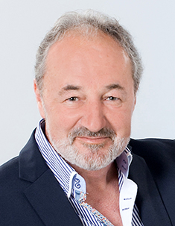
The platform "Easy Life Community & Blockchain Network" is offered by "Sirius Vision Limited" in Ireland, a subsidiary of "Human Ecological Business Holding International Inc. in the USA. The initiator of the unconditional basic income and director of both companies is the Austrian, Mario Eduard Giovanelli.
Website URL's:
Community & shop platform: https://easylife.community
Exchange platform: https://global.easylife.communty
Biography of the initiator: https://easylife.community/en/the-initiator
Contact: Mario Eduard Giovanelli
Email: contact@marioeduardgiovanelli.com
Skype: marioeduardgiovanelli
Phone: +43 (0)664 418 76 00
Companies:
Holding: Human Ecological Business Holding International Inc., Incorporated by the N.Y.S. Department of State - Division of Corporations and State Records on August 8th, 2014, FILE#:140808010174, 90 STATE ST STE 700, Office 40, Albany, NY 12207
Subsidiary: The SIRIUS VISION LIMITED was incorporated on October 12, 2020 and registered with the CRO Company Registration Office in Ireland, Registration number: 679399, COLIEMORE HOUSE, COLIEMORE ROAD, DALKEY, CO. DUBLIN, A96 A8D5, IRELAND

